AP Macroeconomics Free Response Study Guide

- GDP, Business Cycle, and Unemployment.

- Graphing the condition of the Economy.

- Determinants (Shifters of AD and AS).

- Correcting the Problem in the Economy using Fiscal Policy or Classical Thinking

- Correcting the Problem in the Economy using Monetary Policy. Supply and Demand for Money (Money Market)

- Loanable Funds, the Crowding Out Effect, and the Determinants
(Shifters) of the Demand and Supply for Loans
- Interest Rates and Inflation: Nominal vs. Real Interest Rates: CPI and GDP Deflator

- Absolute Advantage & Comparative Advantage.
- The Exchange Market (Shifters of Supply and Demand)
10. Setting up the FOREX Market

11. Important Basic Formulas, and Theories.

12. Balance Sheet of a Bank.

13. The Bond Market: Bond Prices and Interest Rates on Bonds.

14. Balance of Payments. Current Account and CFE
15. Circular Flow.
16. Economic Growth
17. Memory Aids
18. Basics of Supply and Demand (Review)
AP Macroeconomics Free Response Study Guide

1. GDP, Business Cycle, and Unemployment

GDP
The most important measure of growth is GDP. Gross Domestic
Product (GDP) is the dollar value of all final goods and services
produced within a country’s borders in one year.

Dollar value- GDP is measured in dollars.
Final Goods-GDP does not include the value of intermediate goods. Intermediate goods are goods used in the production of final goods and services.
One Year-GDP measures annual economic performance.

AD at AS = GDP = C + I + G + X - M

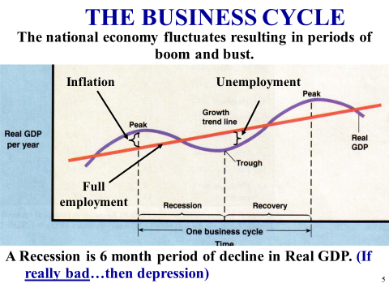

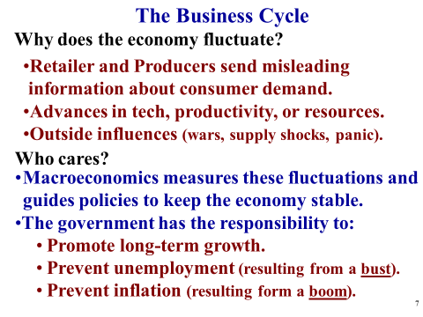
Unemployment
3 Types of Unemployment
- Frictional Unemployment = Temporarily unemployed or being between jobs, but are qualified workers … examples: recent graduates, someone who quit or was fired from their job. Seasonal unemployment is a subset of Frictional.
- Structural Unemployment = Changes in the structure of the labor force make some skills obsolete like changes in technology… examples VCR Repairmen and Carriage makers
- Cyclical Unemployment = Unemployment that results from economic downturns (recessions)… examples: laid off steel workers in a recession or waiters fired because business at the restaurant is bad

Calculating Unemployment

The following table shows labor market data for Country X
Employed | 180,000
Frictionally unemployed | 10,000
Structurally unemployed | 5,000
Cyclically unemployed | 5,000
Not in the labor force | 100,000

- Calculate the unemployment rate:

Unemployed = 10,000 Frictional + 5,000 Structural + 5,000 Cyclical = Total unemployed 20,000
Employed 180,000 + Unemployed 20,000 = 200,000 participating in the labor force
20,000 / 200,000 = 10% Unemployment Rate

- Calculate the labor force participation rate:

Labor force of 200,000 + 100,000 Not participating = 300,000 total population

200,000 / 300,000 66.66% labor force participation rate

(NRU) Natural Rate of Unemployment (Full Employment)

Not zero unemployed! Considered to be 4 – 6 % unemployment in the USA. (Total of Frictional and Structural) Any rate higher than this is Cyclical Unemployment

2...Graphing the condition of the Economy.
- Full employment without high inflation (2 % to 3% inflation is normal)
- Normal Recession (high unemployment with low or no inflation)
- Demand Pull Inflation (past full employment which is 5% unemployment, and with only 3% unemployment temporarily)
- Cost Push Inflation ( also has higher than normal unemployment)
- Condition of the economy using the Phillips Curves
- Condition of the Economy using the Production Possibilities Curve

2A. Full employment without high inflation (2 % to 3% inflation is normal). The important part of this, is that you use a vertical section or a separate long-run vertical AS curve, which shows the full employment (Natural Rate of Unemployment at the bottom of LRAS)

Full Employment
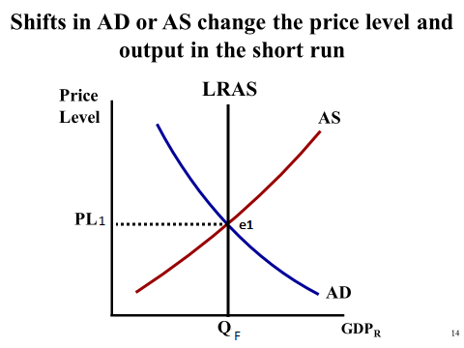
2B. Normal Recession (high unemployment with low or no inflation)
Negative Output Gap or
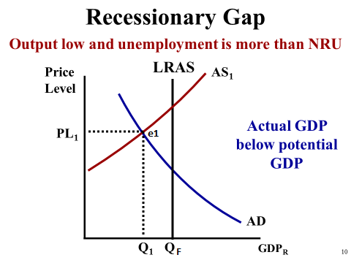
This indicates a recession, where Q1 is less than QF (which is full employment). As GDP decreases unemployment increases

2C. Demand Pull Inflation (has full employment
Positive Output Gap or
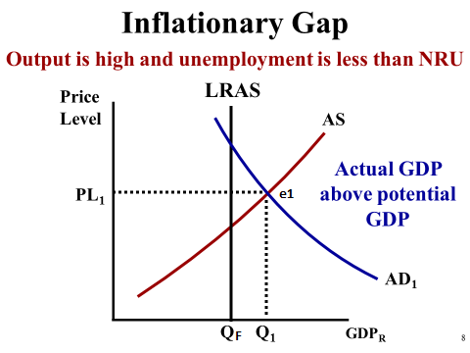

Note: This is an overheated economy (inflationary). 3% unemployment is unusually low and can’t be sustained. It is temporary. The AS will eventually shift (left) back to QY because workers will insist on higher wages because of inflation and they will get higher wages

2D. Cost Push Inflation (also has higher than normal unemployment)
Example: 8% inflation with 7% unemployment. Make sure you show QY (full employment). Note: Classical economists believe workers will take lower wages so the supply curve will eventually shift back to YF.

Cost Push Inflation has a
Negative Output Gap
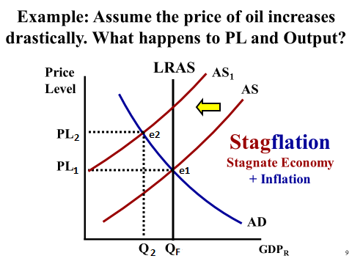

1E. Condition of the economy using the Phillips Curve
Note: in the ADAS Model along the “X” axis GDP increases from left to right, so unemployment decreases from left to right. In the Phillips Model the direction of unemployment is reversed so unemployment increase from left to right. AS a result, in the Phillips Model the SRPC is the “Mirror Image” of the SRAS Curve. As points move on the SRPC there is a tradeoff between Inflation and Unemployment. There is no tradeoff in the long-run. Also Note: If the SRAS Curve shifts the SRPC curve shifts in the opposite direction.

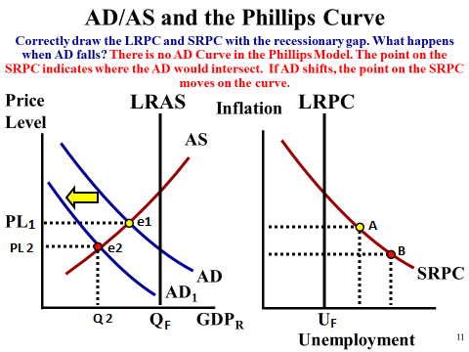

NOTE: That Unemployment Rate gets smaller from left to right in the ADAS Model. It is the opposite in the Phillips Model, the unemployment rate gets larger from left to right. AS a result the SRPC is essentially the mirror image of the SRAS curve. IF SRAS were to shift right, then the SRPC would shift to the left.

2F. Condition of the Economy using the Production Possibilities Curve
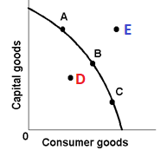
Points A, B, and C represent full employment (4 to 6% unemployment/ the “Natural Rate of Unemployment”). Point D inside the curve represents high unemployment (not operating at full output). Point E represents an unattainable point in the short-run. Point E can be reached in the long-run through economic growth.
Moving from one point on the curve to another on the curve necessitates that you give up the production of some capital goods or consumer goods to gain more of the other. (What you give up is your opportunity costs). All of the possible points you can produce at on the curve represents trade-offs.

3…Determinants (Shifters of AD and AS)

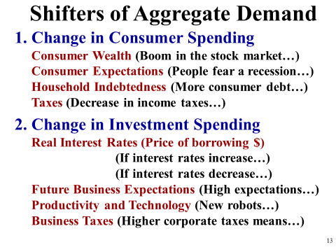
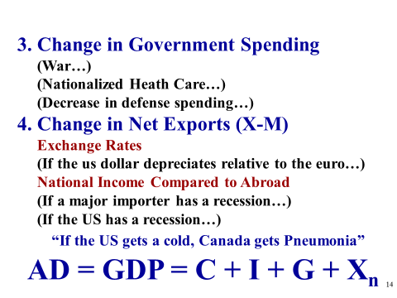

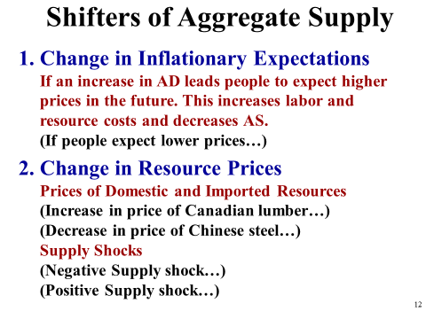
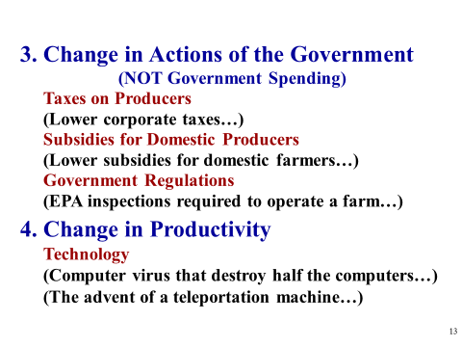

4…Correcting the Problem in the Economy using Fiscal Policy or Classical thinking
- Normal Recession (high unemployment with low or no inflation)
- Demand Pull Inflation (has full employment)
- Cost Push Inflation ( also has higher than normal unemployment)

4A. Normal Recession (high unemployment with low or no inflation)
Three part AS Model (with Keynesian and Classical Thinking)
The Keynesian view is an expansionary Fiscal Policy (Congress & the President) with more government spending and/or tax cuts to increase Aggregate Demand.

AD at equilibrium with AS equals GDP = C + I + G +X -M

Note: Keynes believed that wages and prices are sticky downward, and the economy would be slow to self-correct because of it. If AD intersects AS in
the Keynesian Range we could be stuck in a recession for a long period of time, unless government took action to increase AD by government spending.
The Intermediate Range is the standard SRAS Curve in the ADAS Model where wages and prices are more responsive.
The Classical Range is the LRAS curve in the ADAS Model indicating full employment.

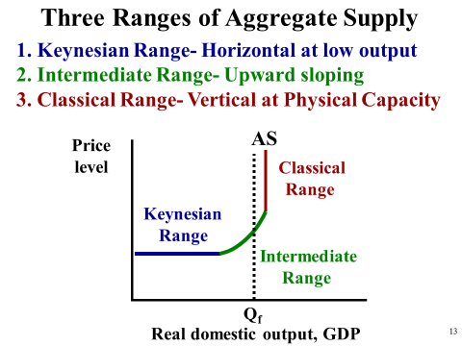

ORIGINAL CLASSICAL THINKING = VERTICAL SUPPLY
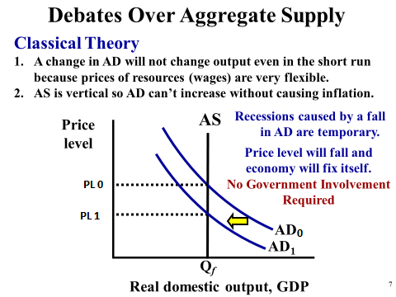

3. Over time the above original thinking evolved, and Neo-Classical thinkers agreed that short-term problems may exist ( SHORT RUN SUPPLY CURVE), but would be corrected as prices and wages adjusted. There would be a return to full employment if there were no government interference.

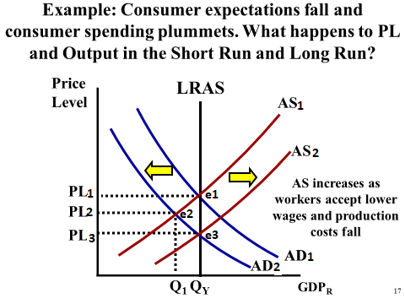

  - “P-WAS”… In Classical Thinking, the theory is that the government should do nothing, and the economy will correct itself, but how does this happen? Through wages adjusting to prices. “P-WAS”… If prices rise, WAGES will rise which causes AS to shift toward LRAS, Or “P-WAS” If prices fall, WAGES will fall which causes AS to shift toward LRAS

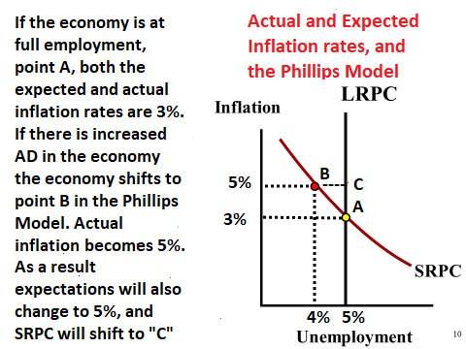

Since, actual and expected (anticipated) inflation has changed from 3% to 5% workers will demand higher wages, and get them. As a result of the inflation Aggregate Supply will shift left in the ADAS Model “PWAS”

4B. Demand Pull Inflation (has full employment)
The Keynesian view would call for a Contractionary Fiscal Policy (Congress & the President) would reduce government spending and/or increase taxes to slow Aggregate Demand. AD at equilibrium with AS equals GDP = C + I + G +X -M

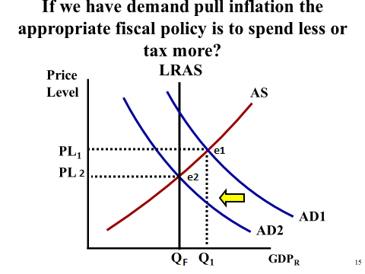

The Classical View is that the economy will self-correct to full employment, just at a higher price level. SRAS will shift to the left due to higher wages. No government action is required.

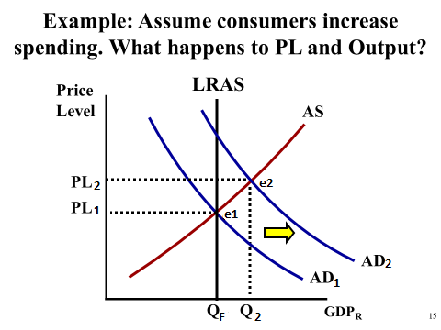
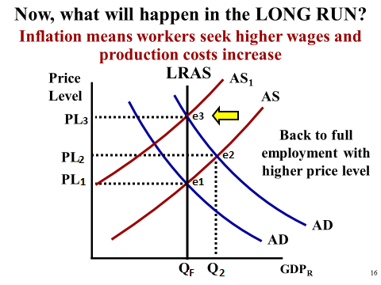

  - “P-WAS”… In Classical Thinking, the theory is that the government should do nothing, and the economy will correct itself, but how does this happen? Through wages adjusting to prices. “P-WAS”… If prices rise, WAGES will rise which causes AS to shift toward LRAS, Or “P-WAS” If prices fall, WAGES will fall which causes AS to shift toward LRAS.

4C. Cost Push Inflation ( also has higher than normal unemployment)
Note: This is mainly an Aggregate Supply problem, like high resource prices (oil). Fiscal Policy is less effective in this situation. The goal is to slow inflation first. The “FED” would raise interest rates to slow inflation. Classically speaking, workers would take lower wages to save their jobs and help move the AS from AS2 back to AS1 and QY as illustrated below.

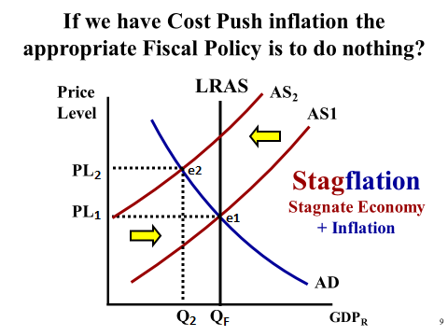

5...Correcting the Problem in the Economy using Monetary Policy
- Normal Recession (high unemployment with low or no inflation)
- Demand Pull Inflation (has full employment)
- Cost Push Inflation ( also has higher than normal unemployment)
- The Demand for Money

TERMS:
Monetary Base = currency held by the public, plus reserves held by banks
Money Supply = M1 = all liquid money in the economy, readily spendable at a store. (currency and demand deposits)
M2 = other forms of money that are less liquid (M1 plus savings, time deposits, and bonds)
We will be primarily concerned with M1 = Money Supply when we look at the actions of the FED.
5A. Normal Recession (high unemployment with low or no inflation)
The “FED” wants to increase AD back to full employment. They would lower interest rates (Easy Money Policy)
(Shifters of Money Supply M1)
- Lowering the discount rate; the rate the “FED” charges banks for a short term loan (this increases the supply of money)
- Lower the reserve requirement, so banks can lend more; i.e. “Pine Gulch” loans increase the money supply.
- Through the open market operations the “FED” would buy bonds that banks and the public are holding. Note: these bonds were initially issued (Sold) by the U. S. Treasury Dept. to banks and the public to cover deficit spending.

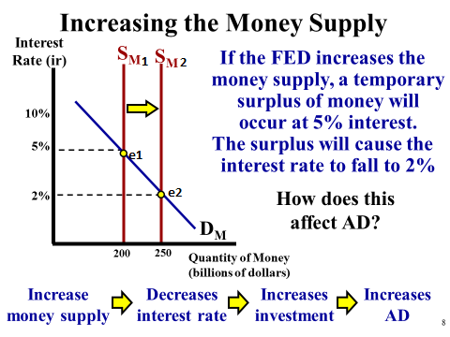
  - Buy Big… When the FED Buys Bonds from the banks or the public the Money Supply increases (Shifts Right)
  - Sell Small… When the FED Sells Bonds to the banks or to the public the Money Supply decreases (Shifts Left)
5B.”FED” Demand Pull Inflation (has full employment)
The “FED” would want to slow down AD by raising interest rates. They would increase interest rates (tight money policy) by;
(Shifters of Money Supply)
- Raising the discount rate, the rate the “FED” charges banks for short term loans
- Raise the reserve requirement, which means that banks would have less excess reserves to loan out. (loans create more money / Pine Gulch)
- Sell Bonds, not newly issued bonds that the Treasury Dept. issues, but rather sell bonds that the “FED” had previously purchased from the public and banks.
The Money Market is short term lending, from bank to bank, i.e.; The Federal Funds Rate, which the “FED” targets to go up or down, by decreasing or increasing the money supply, and has a vertical supply curve. The Fed will actually target a range, say 0.75% to 1.0 %, but banks can charge any rate they wish. However, market forces (competition) will probably put most bank rates within that range. This interest rate, reflects what banks are basically willing to pay for the use of money short term, i.e., loan from another bank or even money people save in the bank.

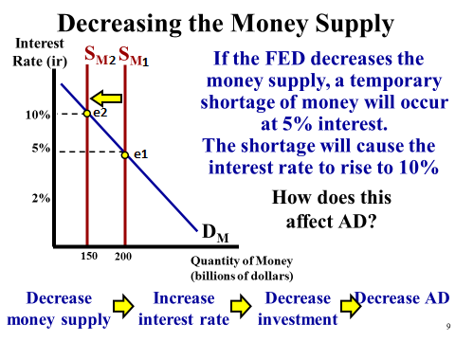
5C. Cost Push Inflation ( also has higher than normal unemployment)
The “FED” would use a tight money policy. The same as 4B above.

5D. The Demand for Money

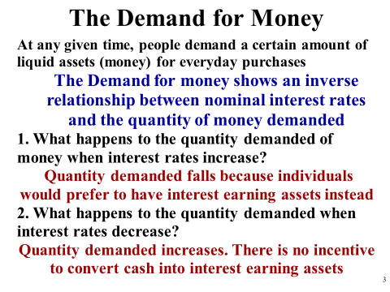
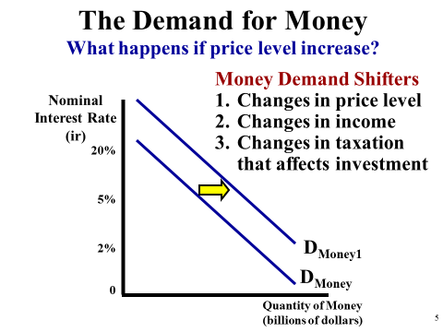

6...Loanable Funds, the Crowding Out Effect, and the Determinants (Shifters) of the Demand and Supply for Loans

Unlike the Money Market, the Loanable Funds Market has an upward sloping supply curve.
The Loanable Funds Market is about long term Loans. (Consumers “C ”, Business “I”, Government “G ”, and Foreigners) GDP=C+I+G+X-M. The supply curve is sloped upward because savers will save more over the long term at higher interest rates than lower interest rates. This increases the “quantity supplied” of money. The interest rate is usually denoted as a “r” (real) in the loanable funds market, and “i ” (nominal) in the money market.

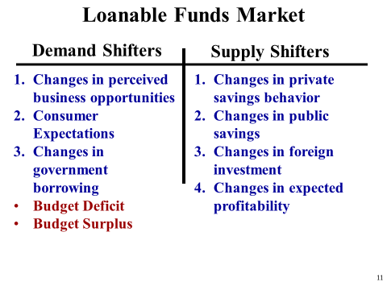

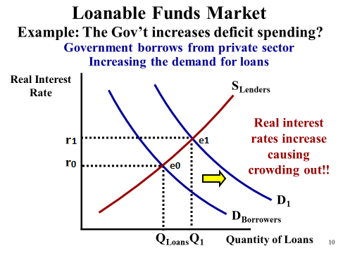

Short Term Effect = Less Aggregate Demand.
If the increased Demand for Loanable Funds comes from government borrowing, by way of “issuing new Treasury Bonds” (the government spending more than it takes in from taxes: deficits ) this will crowd out some consumers and some businesses. That is, the interest rates are too high, and they will not borrow for new cars, equipment etc. This will reduce Aggregate Demand.

Long Term Effect = Slower growth in Aggregate Supply.
This reduced borrowing by business (above) can have an adverse effect on Long Run Aggregate Supply because less capital goods will not be produced, which are important for future growth in LRAS or an expanding PPC, production possibilities curve.

  - Leaning Loanable… The supply curve in the Loanable is leaning like a normal supply curve, where as in the Money Market graph the supply curve is vertical., because people will hold less and save more at higher interest rates.
  - 7… Interest Rates and Inflation: Nominal vs. Real Interest Rates: CPI and GDP Deflator
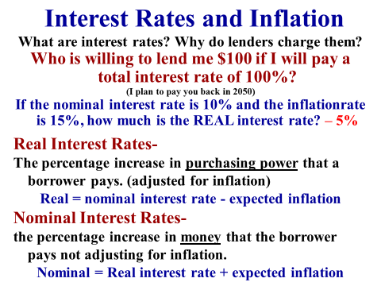
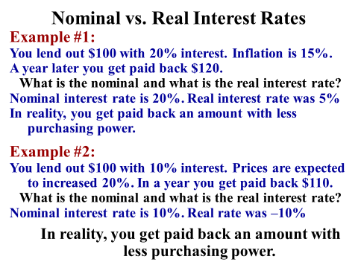

  - NOMINAL is NOW what you actually collect NOW.... REAL is what it is REALLY WORTH in terms of purchasing power.

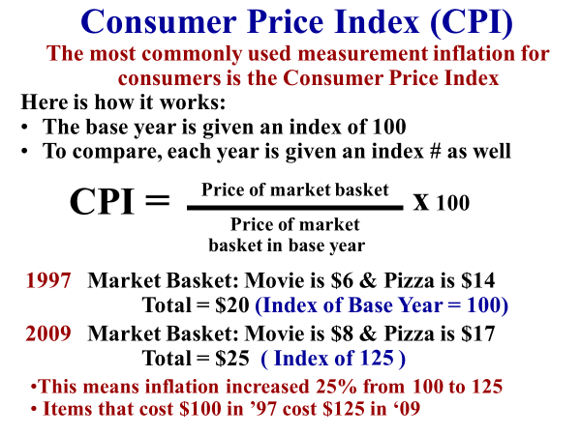
Let’s say that in 2010 CPI increased to 137.50, what was the % increase in inflation from 2009 to 2010. This is a simple calculation of % increase. Take 137.50 – 125 = 12.5 /125 = 10% increase for that year. From 1997 the total % increase for all of those years combined would be 37.5%.
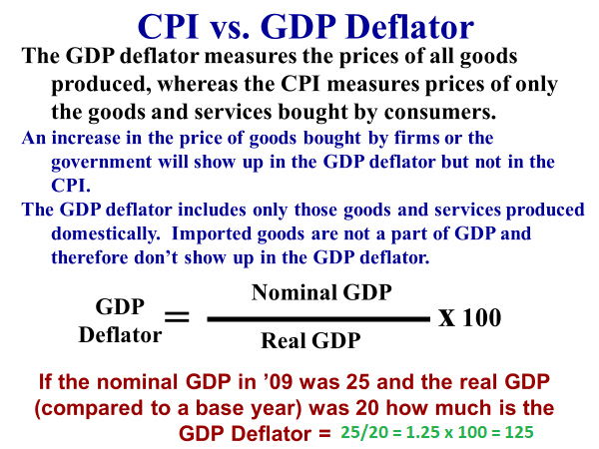

8… Comparative Advantage: Cows and Pigs Terms of Trade
- Country “A” can raise 100 cows or 50 pigs.
- Country “B” can raise 80 cows or 20 pigs
- Country “A” has the absolute advantage in the raising both cows and pigs

 | Cows | Pigs
Country A | 100 so 1 cow =  50/100= ½ pig | 50 so 1 pig =  100/50 = 2 cows
Country B | 80 so 1 cow =  20/80= ¼ pig | 20 so 1 pig =  80/20 = 4 cows

“A” gives up 2 cows to raise a pig: other over 100/50 …
in other words… WE GIVE UP 100 cows / IF WE RAISE 50 pigs …
100 / 50 = 2 cows given up to raise 1 pig
“B” gives up 4 cows to raise a pig: other over 80/20
”A” gives up the least (2 cows) which is the lowest opportunity cost, so they should specialize in pigs, and B should specialize in cows.
Note: For a “quick solution”, or to check your work, simply cross multiply on your grid, and the highest result will give you the correct combination of comparative advantages, i.e. 100 x 20 = 2000 and 80x 50 = 4000. So 80 and 50 are the desirable ways to specialize.
After specialization, what would be good terms of trade for both? You need to know the opportunity costs to solve this.
Country “A” would be happy, if they received anything more than 2 cows for a pig.
After specialization, Country “B” would have to give up 4 cows domestically to get one pig, so they would be happy if they gave up anything less than 4 cows to get a pig.

Ideal terms of trade would be… Country “B” gives up 3 cows to Country “A” for one pig. Country “A” gets more than 2, and Country “B” gives up less than 4.Both Countries are better off.
Ideal terms of trade are between the opportunity costs. Anything between 2 or 4 cows for a pig both countries benefit in in this example.
INPUT PROBLEMS… If we are dealing with the amount of time it takes to produce an item, instead of how much is produced (OUTPUT EXAMPLE above Cows vs. Pigs) then we want to produce in the quickest way possible. Eliminate the slowest times (other goes UNDER to calculate the opportunity costs) when you cross multiply use the smallest product, and good terms of trade would still be any number between the opportunity costs.
NOTE: No Comparative Advantage exists if both countries have the same opportunity costs for both products.
9…The Exchange Market (Shifters of Supply and Demand)
Foreign Purchases: Things that affect exports, imports, and flow of money.
There are the four things that primarily impact the foreign flow of currencies.
1. Income....... If we earn more, we will buy more foreign
2. Relative price levels of similar goods (Inflation)....... If their prices are cheaper, we will buy more foreign
3. Tastes… peoples preferences
4. Changes in interest rates.......If their interest rates are higher, we will put our savings in their banks

1... Changes in Income : If AD increases, for any reason, incomes are increasing and we will purchase more of everything including imports. More imports means that Aggregate Demand and GDP will decrease somewhat. (GDP = C+ I + G + X - M )
Remember “M” is a minus to AD / GDP.
This is the "net export effect". If government pursues an expansionary fiscal policy of more spending and/or lower taxes, there will not be the full impact that we hoped for, because of this foreign pull back on Aggregate Demand. This, however, will not negate or offset the expansionary fiscal policy, just not allow it to have the full impact.
2... Relative price levels of similar goods (Inflation) : Obviously, if foreign goods are cheaper, we will have more demand for them, and the foreign currency. Conversely, if foreign goods are more expensive, we will have less demand for them and their currency.
3. Tastes… peoples preferences. The do or don’t prefer California wine, etc.
4. Changes in interest rates : If U.S.A. interest rates are higher relative to foreign countries, there will be a flow of money to the U.S.A. for savings, and / or interest earning CD's etc. This will appreciate the value of the $, as there will be more demand for the $. After the $ appreciates foreign goods and services will be cheaper for us, and we will import more.
10…How to setup the FOREX graphs
Setup the FOREX “For the $”. This means the $ goes on the horizontal or “X” axis
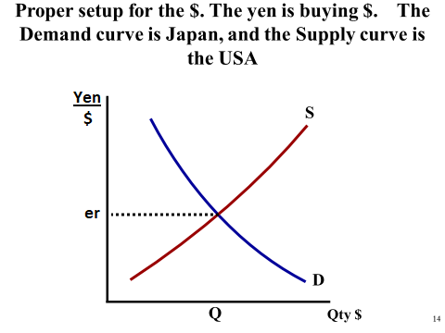

If the scenario involves Japan either buying or not buying then the Demand Curve Shifts.
If the scenario involves the USA buying or not buying then the Supply Curve Shifts.

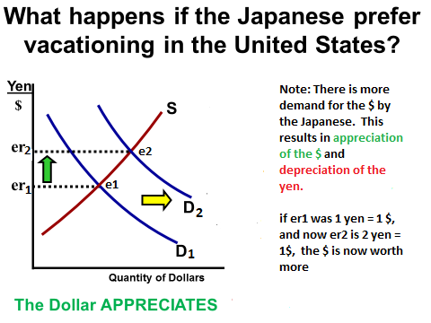
In the graph above “er” indicates the equilibrium rate of exchange.
(A)…After the shift in Demand it now takes more yen to buy a Dollar. (Yen Depreciates) In other words the Dollar can now be exchanged for more yen. ($ Appreciates)
So what happens to exports and GDP after the change in currency valuations?
Use the memory aid “ALE”… if a currency appreciates, then that country will have less exports (it now takes 2 yen to buy a $). If there are now less exports by the USA, the USA GDP will decline… AD at AS = GDP = C + I + G + (X –M)
(A)… The shifts in the curves are dependent upon how you are instructed to setup the FOREX graph, then ask yourself which country(s) is (are) taking action as a result of the scenario. If instructed to set it up for the $, then the dollar goes on the “X” axis, and the yen buying the $ (yen/$) on the “Y” axis.

OR

(B)… If instructed to set it up for the yen, then the yen goes on the “X” axis, and the $ buying the yen ($/yen) on the “Y” axis. In this case, the yen is the supply curve and the $ is the demand curve. So the Japanese are vacationing in the USA and they will need to “supply” more yen to the market to buy $

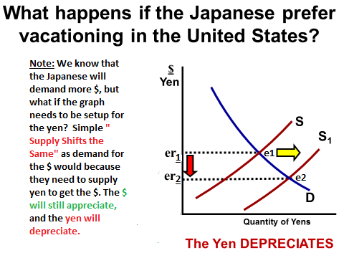

- Note: SSS (SSS = Supply Shifts the Same) Demand and Supply curves always shift in the same direction on the separate graphs, for the stated scenario!

ANOTHER EXAMPLE : If the graph is setup for $ on the horizontal X axis, and the USA is going to buy less European products because European products are more expensive, you should realize that the USA would DEMAND less Euro’s (demand shift to the left) if the graph were setup for the Euro, but it isn’t, it is setup for the $, so supply shifts left.

It is setup for the $, and the $ is now the supply curve. Simply, SSS applies. The supply for the dollar would shift to the left to buy less Euro’s, the same directional shift as demand would have been, if setup was for the Euro.

  - “ ALE ” … APPRECIATION of a currency means that country will have LESS EXPORTS, which means GDP will Decrease; i.e. GDP = C+I+G+X-M

11. Important Basic Formulas, and Theories

GDP = C + I + G + ( X –M)
C = Consumption or also referred to as consumer spending
I = Investment, or also referred to as business spending on new buildings, equipment, and inventories. This is not investment in the sense of the purchase of stocks.
G = Government spending, from all levels of government combined (Federal, State, and Local)
X = Exports, Goods and services that we sell to foreigners
M = Imports, Goods and services that we buy from foreigners

M V = P Q (Monetarists)
M = M1 money supply, V = Velocity of money, PQ = GDP
Monetarists, are neoclassical economists, who believe that “V” is fairly constant. “V” represents how many times money changes hands on average in the economy in one year, believed to about 5 times annually, by monetarists.
Example: M = 3 trillion, V = 5 times, which equals PQ = GDP = 15 trillion
If you multiply “V” times the money supply that equals GDP, expressed here as (P) price times (Q) quantity. They feel that the “FED” should not be active in trying to correct problems associated with the business cycle (unemployment or inflation). They believe that the “FED” does more harm than good, which was true during the Great Depression. Just like other classical economists they believe that the economy will self-correct. They believe that “FED” should just increase money supply at a rate of about 2-3% per year to accommodate real economic growth, irrespective of the condition of the economy. They contend that increasing it more than that will only cause “nominal GDP” to rise, in other words cause inflation.
Opponents of this theory contend that “V” fluctuates, so if “V” is low and the “FED” increases money supply it will not cause inflation. Data for the years during and after the 2009 recession seems to support that.
Rational Expectations Theory (Neo-Classical)
The theory is that people tend to anticipate the consequences of any change by government, and that outcomes depend partly on what people expect to happen, so this will negate or frustrate attempts by government to correct problems in the economy.
For example if during a recessionary gap the “FED” attempts to increase the money supply and lower rates, businesses will quickly raise their prices in anticipation of inflation (AS supply shifts left), and in response workers will raise wage demands to compensate for the inflationary impact of the increase. Theoretically, the attempt at stimulus will be completely offset by the contractionary effects of cost push inflation. See video link below…
https://www.youtube.com/watch?v=TDzrswbPrfE

M = 1/MPS : Government Spending Multiplier
“M” is the multiplier of spending. MPS is the marginal propensity to save.
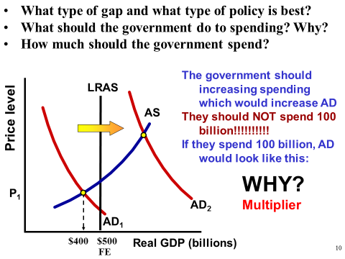

If business spends (invests), or if government spends an additional $20 million, this becomes someone’s income. The question is, if the MPS is 20% in the economy how much total GDP will result. Just divide the MPS of .20 into 1 to get the multiplier of “5”. 5 times $20 million = $100 million in TOTAL SPENDING (GDP). This includes the initial spending of $20 million, or in other words $80 million of additional spending is created by the multiplier.

MM = 1/RR or also stated as M = 1/R : Banking System Lending Multiplier
MM is the money multiplier, RR is the required reserve ratio.
A new deposit of $1000 with an RR ratio of 10% means that the bank can’t lend out $100 of the customer’s deposit. They can only lend out $900.
To determine the amount of additional money created potentially through lending divide .10 into 1 to get a “M” multiplier of 10. Multiply the excess reserves of $900 x 10 = $9000 addition money created potentially through lending.

12... Balance Sheet of a Bank:

Assets Liabilities
(10%) Required reserves $1000 $10,000 Demand Deposits
Excess Reserves $4000
Loans $3000
Bonds $2000
Total = $10,000 $10,000 = Total
Questions:
1. The bank above has loaned out $3000. How much more can it lend out? $4000
2. If a new customer deposits $100 more in the bank. How much of the $100 can it lend out? $90 because the bank is required to hold 10% in reserve ($10)
3. As a result of the $100 deposit, what is the maximum amount of lending the banking system as a whole can lend out of just that $100 deposit? $900 The multiplier is 10 (M= 1/RR) or (M =1/.10 =10), so 10 times $90 = $900
4. As a result of the $100 deposit, what is the maximum amount of Demand Deposits the banking system as a whole could receive, including the initial deposit of $100? $1000 The $900 in additional lending in #3 above + the initial $100 deposit
5. As a result of the $100 deposit, what would be the maximum change in the money supply? $900 same as #3 above because the initial deposit is already part of the money supply
6. Suppose there is no additional $100 deposit, and we are only working with the bank statement above, and that the FED buys the $2000 worth of bonds from the bank. How much can the total money supply potentially increase by using only the $2000 provided by the FED? $20,000 the multiplier being 10; so 10 times the $2000 from the FED. The $2000 from the FED is new money to the banking system.
7. Provide a reason why the actual change in money supply might be less than the $20,000 in #6 above. Customers who receive loans may not deposit the money in a bank, thereby reducing the lending multiplier.
8. If a bank runs low on required reserves (10%), They can borrow money to make up the short fall in required reserves…
For example, if the customer above withdraws $5000, the bank is wiped out of required reserves and excess reserves leaving $0 cash on hand. The bank can borrow, which is a liability to the bank, from either another bank (Federal Funds Rate) or the FED (Discount Rate) to meet the required reserve. There is no required reserve on bank borrowing, only on customer Demand Deposits.
See below…
Assets Liabilities
(10%) Required reserves $500 $5000 Demand Deposits
Excess reserves 0 $500 borrowing from the “FED”
Loans $3000
Bonds $2000
Total = $5500 $5500 Total

Basically they will ask a “Money Supply” question like this 3 different ways….
NOTE: that in all cases, calculate the multiplier and the maximum amount of lending that can be done (this amount is new money and new deposits), then
you need to decide if the initial inflow is new money and/or new deposits depending upon the question.

13. The Bond Market: Bond Prices and Interest Rates on Bonds
The U.S. Treasury Department issues new bonds to cover deficit spending (the government’s credit card in essence). If they issue a $10.000 bond that pays 5% per year interest, then the holder of the bond (the public, banks, and other companies, even foreigners) receives $500 per year in interest. Say that you purchased this bond from the government 4 years ago. (you essentially loaned the government $10,000).
Now assume that today the Treasury is issuing new bonds at 10%. Will anyone buy your bond from you for $10,000? Absolutely not! They can buy a new bond from the Treasury that will pay $ 1000 per interest. They would lose $500 a year in interest income.
If you sell your bond, you will have to sell it for less than the $10,000 that you originally paid for it.
Note: Bonds prices move in the opposite direction of interest rates. Their prices fall when new bonds are paying a higher rate of interest, and vice versa.
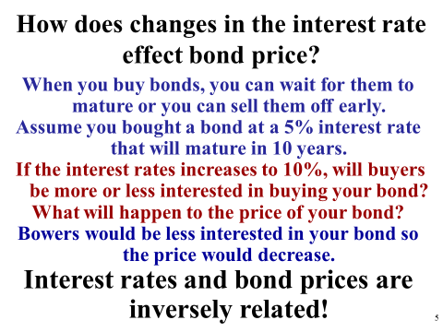

14... Balance of Payments. A trade deficit is where a country imports more than it exports. The U.S. Balance of Payments is made up two parts.

1... Current Account,which is primarily the importing and exporting of goods and services. We have a trade deficit. We buy more imports (outflow of $) than we sell or export (inflow of $)

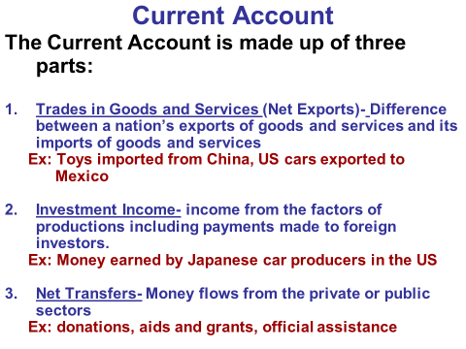
2.Capital Account sometimes called the Financial Account, which is primarily financial assets like stocks, bonds, & CD’s. We have a surplus in our capital account, which offsets our trade deficit (goods & services)

CFA
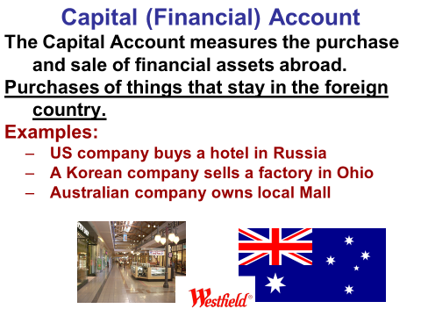

Note: Many people are troubled our trade deficit, and by the fact that foreigners are using those $ to buy up financial assets in the U.S.

15…Circular Flow
This is the idea that we are dependent upon one another. One persons spending is someone else’s income. We buy products from business, they derive income. We supply our labor resource to business, and they pay us income.
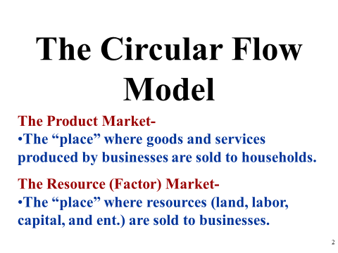
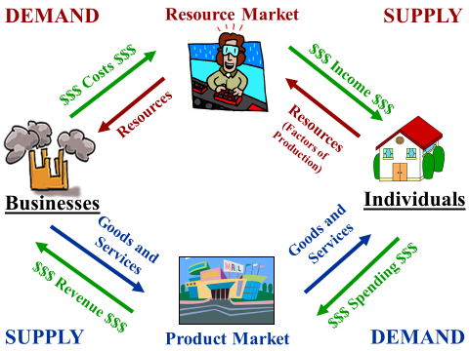
16... Economic Growth
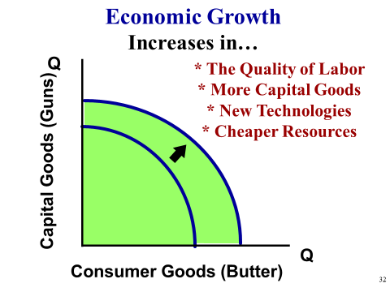
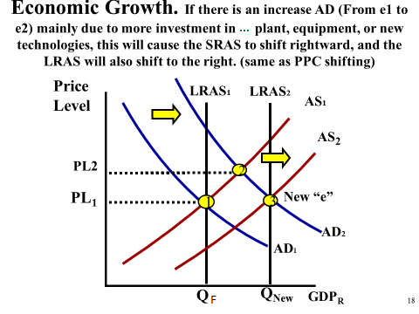

Aggregate Production Function

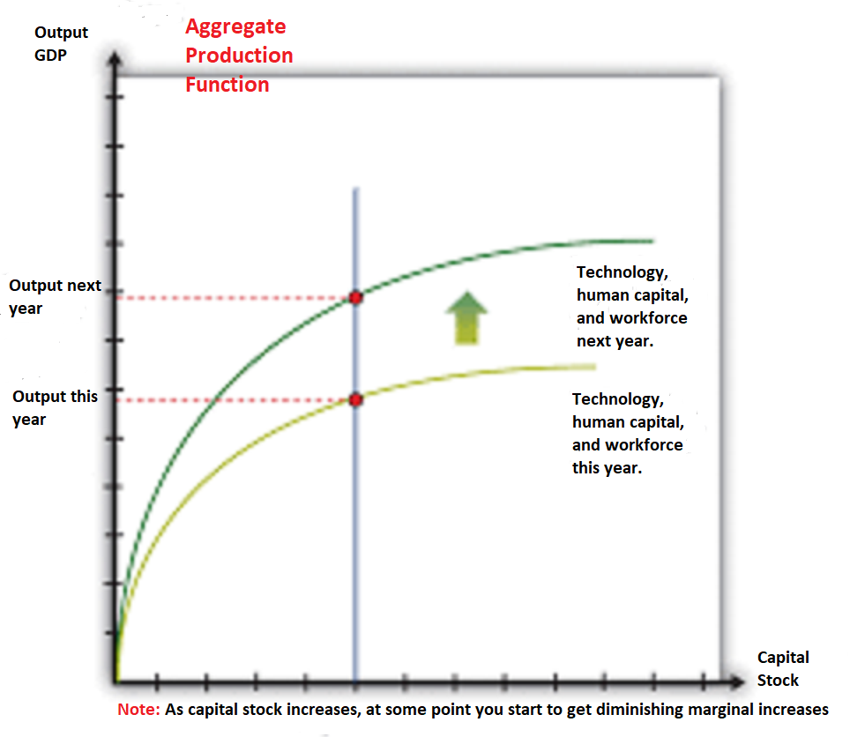

The aggregate production function describes how total real gross domestic product (real GDP) in an economy depends on available inputs. Aggregate output (real GDP) depends on the following: Physical capital—machines,production facilities, and so forth that are used in production.

17. Memory Aids…
  - Buy Big… When the FED Buys Bonds from the banks or the public the Money Supply increases (Shifts Right)
  - Sell Small… When the FED Sells Bonds to the banks or to the public the Money Supply decreases (Shifts Left)
  - Leaning Loanable… The supply curve in the Loanable is leaning like a normal supply, where as in the Money Market graph the supply curve is vertical
  - “ALE ” … APPRECIATION of a currency means that country will have LESS EXPORTS, which means GDP will Decrease; i.e. GDP = C+I+G+X-M
  - SSS (SSS = Supply Shifts the Same) Demand and Supply curves always shift in the same direction on the separate graphs, for a stated scenario! Example: If there is more demand (demand shifts right) by Japan for the ($) on the “X” axis, then if asked to set the graph up with the ($) on the “Y” axis and the yen on the “X” axis, Japan will supply more yen to get $. (Supply shifts right)
  - NOMINAL is NOW what you actually collect NOW.... REAL is what it is REALLY WORTH in terms of purchasing power.
  - “P-WAS”… In Classical Thinking, the theory is that the government should do nothing, and the economy will correct itself, but how does this happen? Through wages adjusting to prices. “P-WAS”… If prices rise, WAGES will rise which causes AS to shift toward LRAS, Or “P-WAS” If prices fall, WAGES will fall which causes AS to shift toward LRAS.

- Basics of Supply and Demand (Review)
Price vs. Costs
Price is the selling price to you and me (Consumers)
Costs are the amounts that companies pay for resources (Land, Labor, Capital, and Entrepreneurship)

Changes in the Quantity Supplied or the Quantity Demanded
Changes in the Price cause movement from one point to another point on the curves. If the price decreases consumers will be willing and able to purchase more of the product, but as selling prices decrease suppliers will be willing and able to produce and sell less.
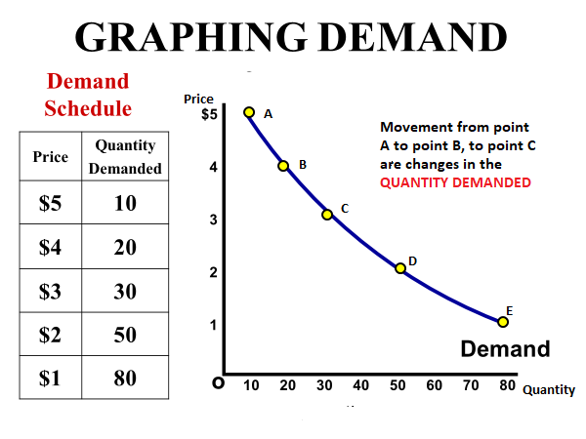

How prices are determined and the Invisible Hand
Surplus: Prices are determined as we move to an equilibrium point in the market. For example; if suppliers produce more than consumers want at a particular price (surplus) there is a signal (Invisible Hand) sent to suppliers. Products are sitting on the shelves and not selling very quickly. Suppliers react by lowering the selling price, which attracts more buyers, moving us toward an equilibrium rice.
Shortage: For example; if suppliers produce less than consumers want at a particular price (shortage) there is signal (Invisible Hand) sent to suppliers. Products are selling very quickly. Suppliers react by raising the price and producing more, which reduces the quantity demanded, moving us toward an equilibrium rice.

Shifts in Supply and Demand
Shifts in Demand: Any non-price change can alter your desire to purchase. Example; if SUV’s double their gas mileage it would increase your desire to purchase. (shift to the right along the quantity line). If it is learned that SUV’s have a poor safety record it would decrease your desire to purchase (shift to the left along the quantity line)
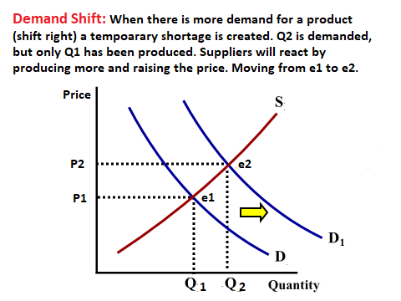

Shifts in Supply: Any change in costs can alter supplier’s ability to sell at the current price and continue to make a profit. Example; if the cost of steel increases to suppliers they will increase the selling price of the SUV’s. (shift to the left along the quantity line). If, however, the cost of steel decreases, SUV producers can lower their selling prices and sell more cars and still make a profit (shift to the right along the quantity line)
